SUPPLEMENTAL MATERIALS

Supplemental Material 1. The descriptive statistics, skewness and kurtosis of variables
Variables | Mean±SD | Min | Max | Skewness | Kurtosis
Job Demand (1~4)
S1 | 2.44±0.65 | 1 | 4 | 0.55 | -0.04
S2 | 2.67±0.72 | 1 | 4 | 0.17 | -0.51
S3 | 2.90±0.62 | 1 | 4 | -0.17 | 0.17
ERI (1~4)
S4 | 2.73±0.58 | 1 | 4 | -0.71 | 0.8
S5 | 2.72±0.41 | 1 | 4 | -0.44 | 0.35
S6 | 2.71±0.59 | 1 | 4 | -0.6 | 0.53
Burnout (1~7)
B1 | 3.02±1.56 | 1 | 7 | 1.56 | 2.42
B2 | 2.99±1.63 | 1 | 7 | 0.67 | -0.42
B3 | 3.54±1.82 | 1 | 7 | 0.29 | -1.01
B4 | 3.12±1.77 | 1 | 7 | 0.59 | -0.67
B5 | 2.90±1.68 | 1 | 7 | 0.84 | -0.11
Trauma (1~5)
T1 | 2.93±1.01 | 1 | 5 | -0.03 | -0.65
T2 | 2.29±0.99 | 1 | 5 | 0.47 | -0.36
T3 | 2.50±1.00 | 1 | 5 | 0.38 | -0.49
T4 | 2.49±0.95 | 1 | 5 | 0.45 | -0.39
T5 | 2.18±0.98 | 1 | 5 | 0.71 | 0.1
Violence (1~4)
V1 | 2.66±0.76 | 1 | 4 | -0.44 | -0.06
V2 | 1.84±0.63 | 1 | 4 | 0.49 | 0.99
V3 | 2.28±0.77 | 1 | 4 | 0.08 | -0.44
V4 | 2.14±0.72 | 1 | 4 | 0.34 | 0.06
V5 | 1.89±0.68 | 1 | 4 | 0.46 | 0.31
PTSD score (0~51) | 4.31±6.05 | 0 | 48 | 2.55 | 9.54

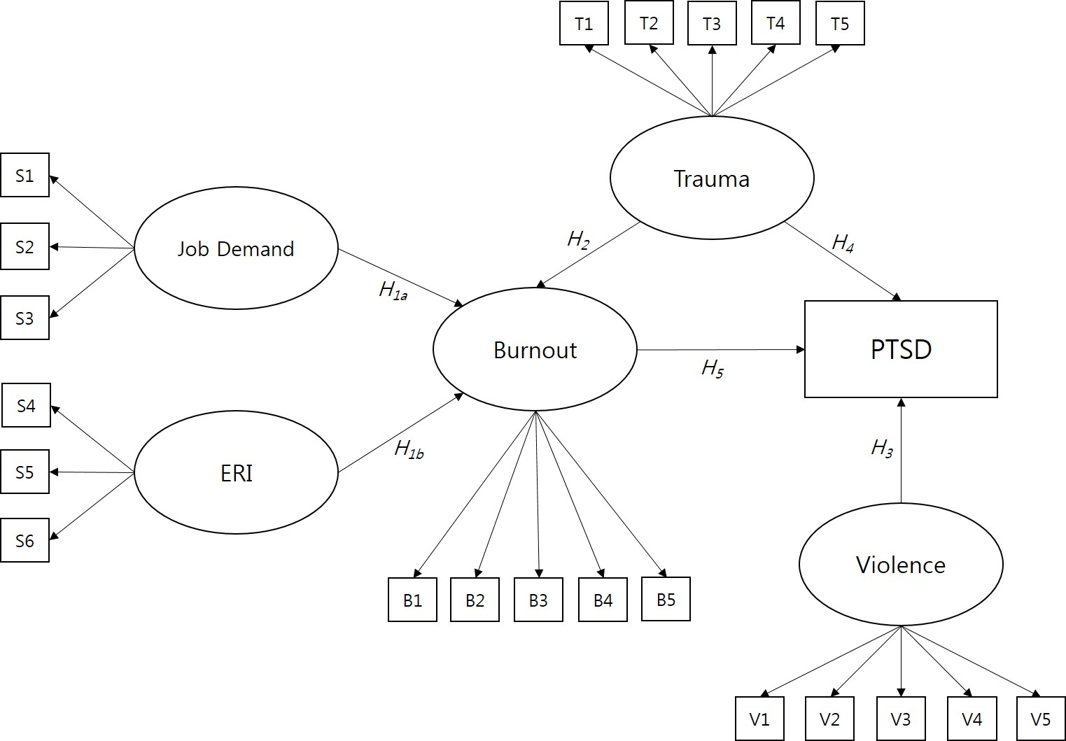
Supplemental Material 2. Specification of a structural equation model for the Effect of Burnout on PTSD Symptoms in Firefighters, including mediating and effects of trauma. The model was fitted to the self-reported data of firefighters collected in the FRESH study (2016–2017). Rectangles indicate observed variables, and ellipses represent latent variables/constructs. Single-headed arrows indicate a directional effect.

Supplemental Material 3. The summary of goodness of ﬁt indices for the hypothesized SEM model
 | Fit Index | Value
Absolute Fit Index | χ2 | 452.458 (p<.001)
 | GFI (Goodness of Fit Index) | 0.927
 | RMSEA (Root Mean Square Error of Approximation) | 0.049 (0.043, 0.055)
 | SRMR (Standardized Root Mean Square residual) | 0.04
 | ECVI (Expected Cross-Validation Index) | 1.051
Incremental Fit Index | CFI (Comparative Fit Index) | 0.96
 | TLI (Tucker-Lewis Index) | 0.953
 | NFI (Bentler-Bonett Normed Fit Index) | 0.931
 | NNFI (Bentler-Bonett Non-normed Fit Index) | 0.953
 | RNI (Relative Noncentrality Index) | 0.960
 | RFI (Bollen's Relative Fit Index) | 0.919
 | IFI (Bollen's Incremental Fit Index) | 0.960
Parsimonious Fit Index | Normed χ2 (χ2/df) | 2.357
 | AIC (Akaike Information Criteria) | 27291.932
 | AGFI (Adjusted Goodness of Fit Index) | 0.906
 | PNFI (Parsimony Normed Fit Index) | 0.798
 | PGFI (Parsimony Goodness of Fit Index) | 0.725

Supplemental Material 4. Path analysis of the hypothesized SEM model
Hypothesis | Path | Unstandardized parameters |  | Standardized parameters |  | Two-tailed p-value | Acceptancy
 |  | B | SE | β | C.R.
H_{1a} | Job Demand → Burnout | 1.121 | 0.137 | 0.411 | 8.171 | <0.001 | Accept
H_{1b} | ERI → Burnout | -0.944 | 0.148 | -0.290 | -6.368 | <0.001 | Accept
H₂ | Trauma → Burnout | 0.215 | 0.068 | 0.131 | 3.172 | 0.001 | Accept
H₃ | Violence → PTSD | 1.337 | 0.551 | 0.123 | 2.428 | 0.014 | Accept
H₄ | Trauma → PTSD | 0.622 | 0.358 | 0.085 | 1.736 | 0.081 | Reject
H₅ | Burnout → PTSD | 1.060 | 0.200 | 0.237 | 5.308 | <0.001 | Accept
B=Unstandardized estimate; SE=Standard Error; β=Standardized estimate; C.R.: Critical ratio

Supplemental Material 5. Moderating effect of Trauma on PTSD
 | Test Statistic | S.E. | Two-tailed p-value
Sobel test | 2.715 | 0.091 | 0.012
Aroian test | 2.475 | 0.092 | 0.013
Goodman test | 2.551 | 0.089 | 0.011
http://www.quantpsy.org/sobel/sobel.htm
Details can be found in Sobel (1982), Goodman (1960), and MacKinnon, Warsi, and Dwyer (1995).

Figure 2

Supplemental Material 6. Mediation of impact of trauma on PTSD through burnout(left) and result of Sobel test(right).
a = effect of Trauma on Burnout; b = effect of Trauma on PTSD; C = total effect of Trauma on PTSD; Sa = Standard error of path coefficients a; Sb = Standard error of path coefficients b; and a, b and C mean unstandardized parameters. Continuous arrows indicate significant effect while dashed arrows signify non-significant effects.
Trauma
Burnout
PTSD
a(S_{a})
b(S_{b})
C’
Trauma
Burnout
PTSD
0.215(0.074)
1.060(0.212)
0.622(0.361)

