Supplementary Materials

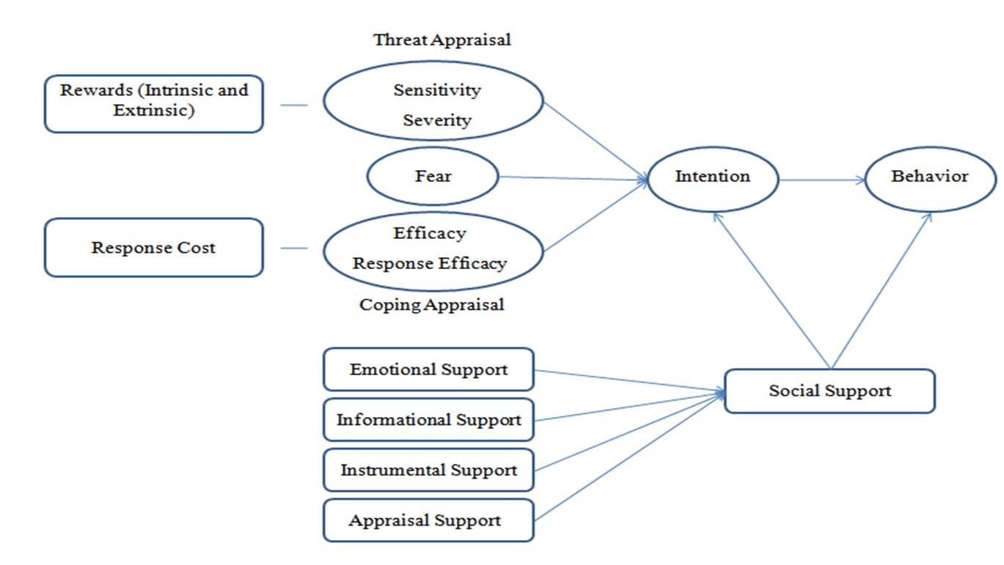
Figure S1. The conceptual model of research, a combination of PMT and social support theory.

