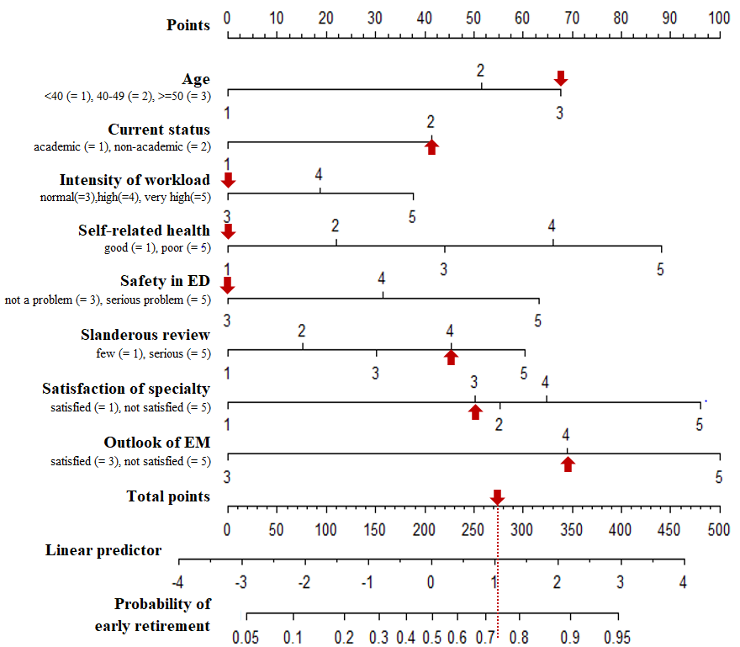
Figure S1. Nomogram probability score of 273 points; Linear Predictor = 1.04; and early retirement intention probability of 74%.
Sample prediction using nomogram and probability equation
Responses as follows: 53-year-old emergency physician working at an emergency room (2), employed at a non-academic hospital (2), below average level of workload intensity relative to other departments (3), in very good perceived health status (1), average emergency room safety (3), patient complaints as the greatest stress source (4), average level of satisfaction with the specialty (3), average expectation in terms of future progress of emergency medicine (4).

