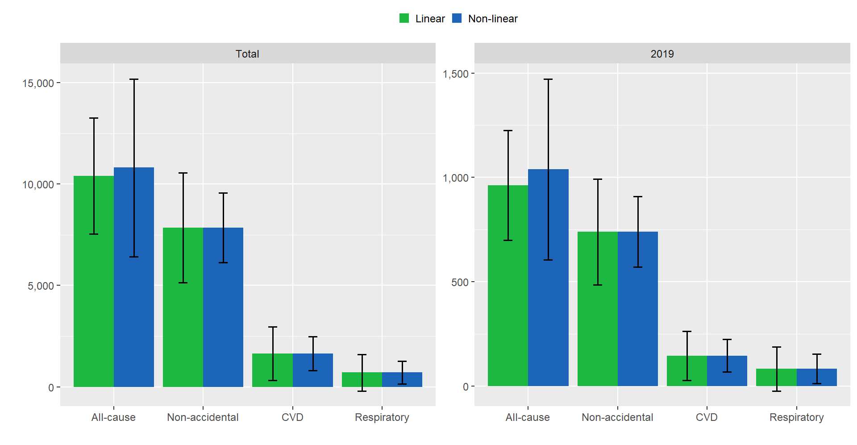
Supplemental Material 8. Excess deaths due to short-term exposure to PM_{2.5} assuming linear and non-linear associations in the whole study period (2010–2019) and in 2019.

