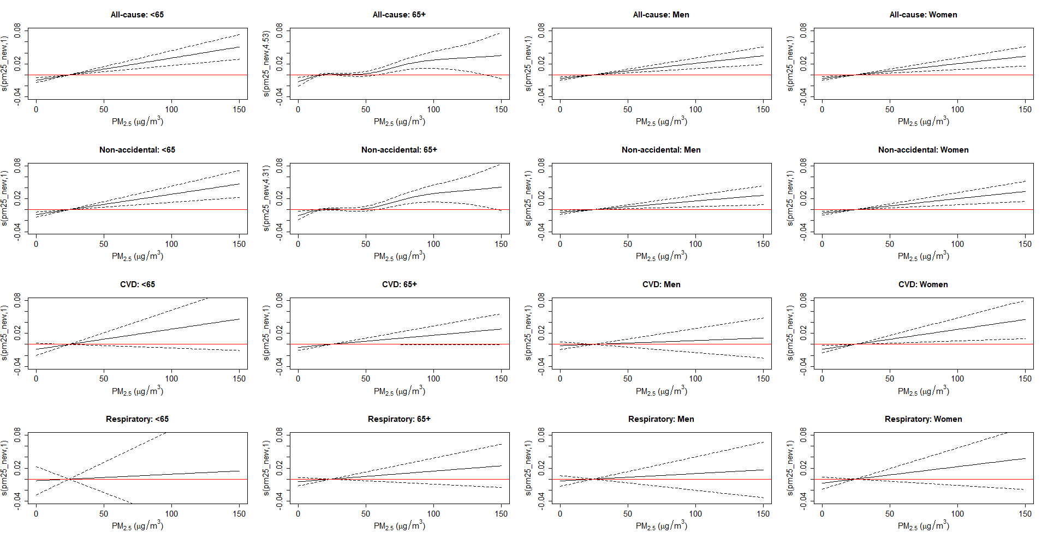
Supplemental Material 10. Exposure–response relationship between daily exposure to PM_{2.5} and cause-specific death by age group and gender in Korea in 2010–2019. Black dotted lines indicate the 95% confidence intervals (CIs).
Abbreviation: CVD, cardiovascular disease; CI, Confidence intervals

