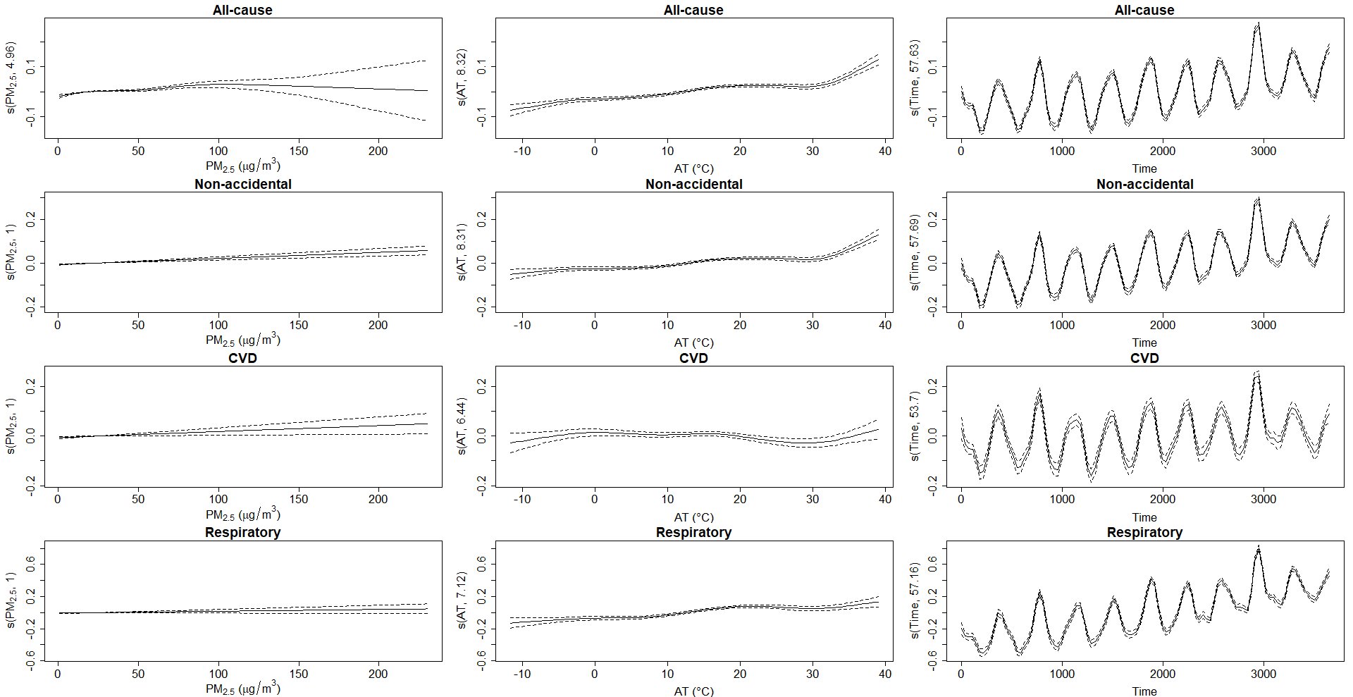
Supplemental Material 1. Penalized splines indicating the relationship between cause-specific mortality and PM_{2.5} concentration, apparent temperature, and time trend parameters.

