A | 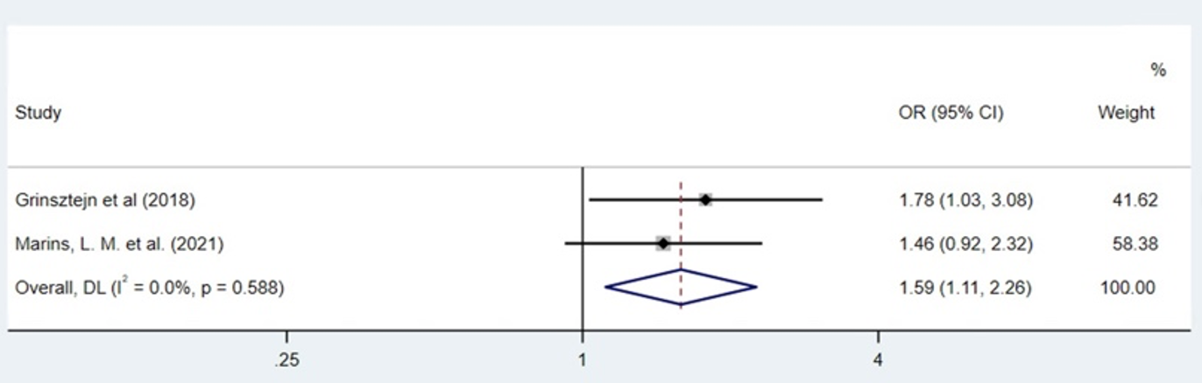
B | 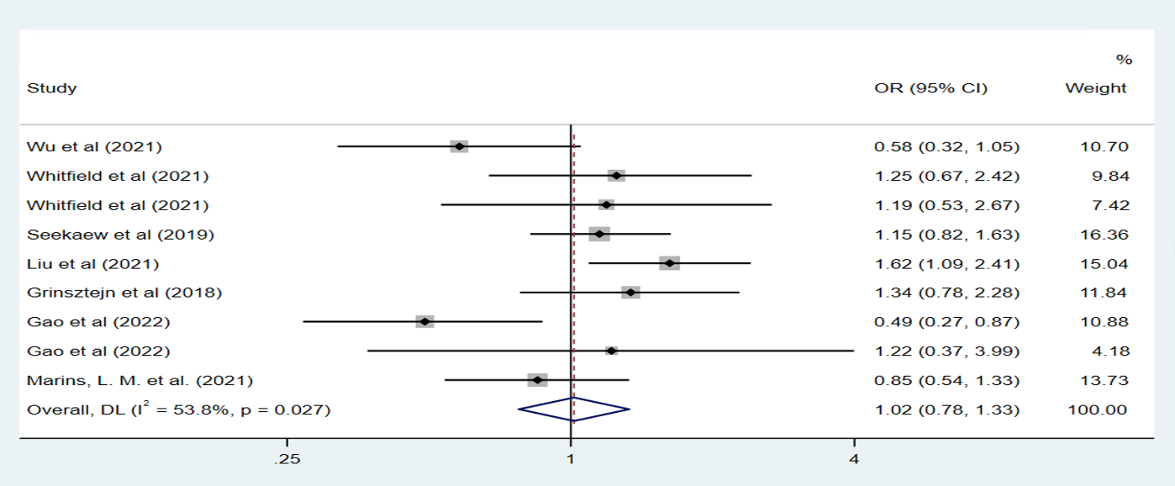
C | 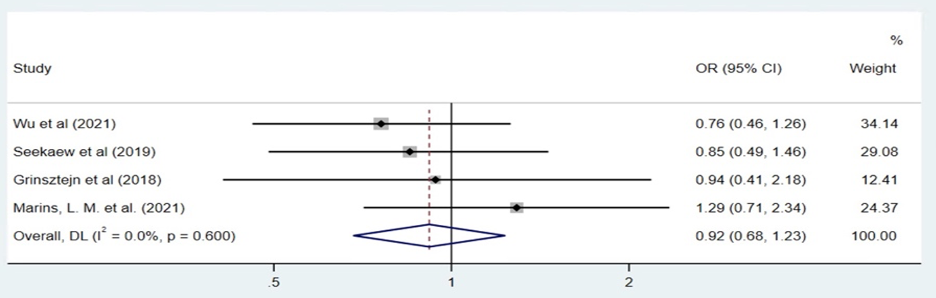

Figure S3. The pooled estimates of PrEP adherence for having sexual encounters with an HIV-positive partner (A), condom use (B), and sexually transmitted infections (C). OR, odds ratio; CI, confidence interval; DL, DerSimonian and Laird.

