Stomach cancer
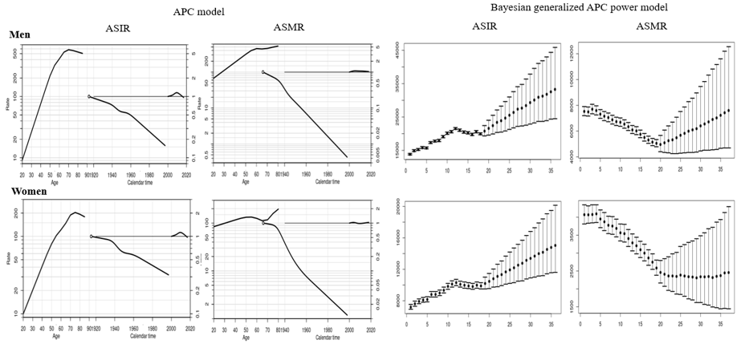
APC analysis | Terms in model | Summary statistics
 |  | Deviance (df) | △D (△ df) | Effect | p-value | Adj-$R^{2}$
Incidence
Men | Age | 6,756.04 (247) | - | - | - | -
 | Age+drift | 3,224.19 (246) | 3,531.85 (1) | δ | A | < 0.0001 | 0.52
 | Age+period | 2,184.34 (243) | 4,571.70 (4) | P | A | < 0.0001 | 0.67
 | Age+cohort | 2,811.73 (243) | 3,944.3 (4) | C | A | < 0.0001 | 0.58
 | Age+period+cohort | 1,836.99 (240) | 974.74 (3) | P | AC | < 0.0001 | 0.72
 |  |  | 347.35 (3) | C | AP | < 0.0001
Women | Age | 4,129.03 (247) | - | - | - | -
 | Age+drift | 3,100.17 (246) | 1,028.86 (1) | δ | A | < 0.0001 | 0.20
 | Age+period | 2,764.47 (243) | 1,364.56 (4) | P | A | < 0.0001 | 0.78
 | Age+cohort | 2,860.07 (243) | 1,268.96 (4) | C | A | < 0.0001 | 0.28
 | Age+period+cohort | 2,546.30 (240) | 313.77 (3) | P | AC | < 0.0001 | 0.83
 |  |  | 218.17 (3) | C | AP | < 0.0001
Mortality
Men | Age | 20,601.67 (242) | - | - | - | -
 | Age+drift | 1,749.59 (241) | 18,852.08 (1) | δ | A | < 0.0001 | 0.91
 | Age+period | 1,638.35 (238) | 18,963.33 (4) | P | A | < 0.0001 | 0.92
 | Age+cohort | 674.83 (238) | 19,926.84 (4) | C | A | < 0.0001 | 0.97
 | Age+period+cohort | 621.28 (235) | 53.55 (3) | P | AC | < 0.0001 | 0.97
 |  |  | 1,017.07 (3) | C | AP | < 0.0001
Women | Age | 10,893.22 (242) | - | - | - | -
 | Age+drift | 2,808.99 (241) | 8,084.23 | δ | A | < 0.0001 | 0.74
 | Age+period | 2,779.58 (238) | 8,113.64 | P | A | < 0.0001 | 0.74
 | Age+cohort | 1,510.31 (238) | 9,382.91 | C | A | < 0.0001 | 0.86
 | Age+period+cohort | 1,492.45 (235) | 17.86 | P | AC | < 0.0001 | 0.86
 |  |  | 1,287.14 | C | AP | < 0.0001
Abbreviation: df, degree of freedom; △D, difference of deviance; △df, difference of the degree of freedom; δ|A, δ effect adjusted by age; P|A, period effect adjusted by age; C|A, cohort effect adjusted by age; P|AC, period effect adjusted by age and cohort; C|AP, cohort effect adjusted by age and period
Supplemental Material 9. Age, cohort and period effects for the rates of stomach cancer in the age-period-cohort (APC) model (first curve, age effect; second curve, cohort effect; third curve, period effect) and the forecasts of cancer rates in the Bayesian generalized APC power model (x-axis means the calendar year, such as 0=2000, 5=2005, 10=2010, 15=2015 (the year of observation); 20=2020, 25=2025, 30=2030, 35=2035 (the predicted year); y-axis means the number of observed or estimated cancer cases; The fan shows the predictive distribution of cancer cases from the 5% to the 95% value; dot, mean predictive value) (Abbreviation: ASIR, age-standardized incidence rates; ASMR, age-standardized mortality rates).

