Thyroid cancer
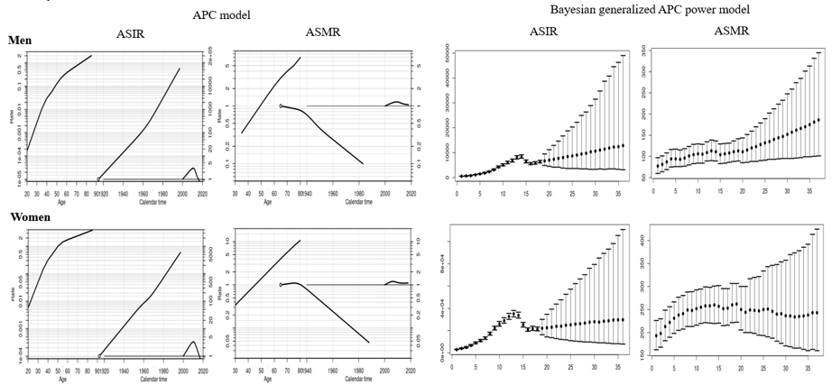
APC analysis | Terms in model | Summary statistics
 |  | Deviance (df) | △D (△ df) | Effect | p-value | Adj-$R^{2}$
Incidence
Men | Age | 29,966.65 (247) | - | - | - | -
 | Age+drift | 12,908.38 (246) | 17,058.27 (1) | δ | A | < 0.0001 | 0.57
 | Age+period | 2,452.68 (243) | 27,513.97 (4) | P | A | < 0.0001 | 0.92
 | Age+cohort | 12,544.51 (243) | 17,422.14 (4) | C | A | < 0.0001 | 0.57
 | Age+period+cohort | 1,691.40 (240) | 10,853.11 (3) | P | AC | < 0.0001 | 0.94
 |  |  | 761.28 (3) | C | AP | < 0.0001
Women | Age | 103,558.10 (247) | - | - | - | -
 | Age+drift | 63,063.40 (246) | 40,494.70 (1) | δ | A | < 0.0001 | 0.39
 | Age+period | 7,188.09 (243) | 96,370.01 (4) | P | A | < 0.0001 | 0.93
 | Age+cohort | 6,237.32 (243) | 97,320.78 (4) | C | A | < 0.0001 | 0.94
 | Age+period+cohort | 6,077.74 (240) | 159.58 (3) | P | AC | < 0.0001 | 0.94
 |  |  | 1,110.35 (3) | C | AP | < 0.0001
Mortality
Men | Age | 328.93 (205) |  | -
 | Age+drift | 254.22 (204) | 74.72 (1) | δ | A | < 0.0001 | 0.22
 | Age+period | 247.74 (201) | 81.19 (4) | P | A | < 0.0001 | 0.23
 | Age+cohort | 241.26 (201) | 87.68 (4) | C | A | < 0.0001 | 0.25
 | Age+period+cohort | 236.83 (198) | 4.43 (3) | P | AC | < 0.0001 | 0.25
 |  |  | 10.92 (3) | C | AP | < 0.0001
Women | Age | 463.66 (205) |  | - | - | -
 | Age+drift | 314.25 (204) | 149.42 (1) | δ | A | < 0.0001 | 0.32
 | Age+period | 296.55 (201) | 167.11 (4) | P | A | < 0.0001 | 0.35
 | Age+cohort | 235.26 (201) | 228.41 (4) | C | A | < 0.0001 | 0.48
 | Age+period+cohort | 226.94 (198) | 8.32 (3) | P | AC | < 0.0001 | 0.49
 |  |  | 69.61 (3) | C | AP | < 0.0001
Abbreviation: df, degree of freedom; △D, difference of deviance; △df, difference of the degree of freedom; δ|A, δ effect adjusted by age; P|A, period effect adjusted by age; C|A, cohort effect adjusted by age; P|AC, period effect adjusted by age and cohort; C|AP, cohort effect adjusted by age and period
Supplemental Material 13. Age, cohort and period effects for the rates of thyroid cancer in the age-period-cohort (APC) model (first curve, age effect; second curve, cohort effect; third curve, period effect) and the forecasts of cancer rates in the Bayesian generalized APC power model (x-axis means the calendar year, such as 0=2000, 5=2005, 10=2010, 15=2015 (the year of observation); 20=2020, 25=2025, 30=2030, 35=2035 (the predicted year); y-axis means the number of observed or estimated cancer cases; The fan shows the predictive distribution of cancer cases from the 5% to the 95% value; dot, mean predictive value) (Abbreviation: ASIR, age-standardized incidence rates; ASMR, age-standardized mortality rates).

