Colorectal cancer
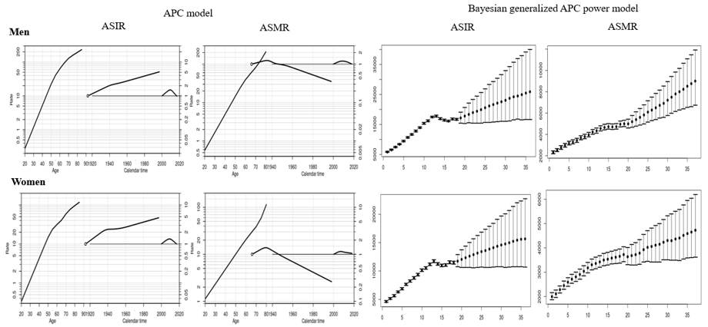
APC analysis | Terms in model | Summary statistics
 |  | Deviance (df) | △D (△ df) | Effect | p-value | Adj-$R^{2}$
Incidence
Men | Age | 6,617.21 (247) | - | - | - | -
 | Age+drift | 5,577.19 (246) | 1,040.01 (1) | δ | A | < 0.0001 | 0.15
 | Age+period | 1,057.35 (243) | 5,559.86 (4) | P | A | < 0.0001 | 0.84
 | Age+cohort | 5,267.51 (243) | 1,349.70 (4) | C | A | < 0.0001 | 0.19
 | Age+period+cohort | 927.21 (240) | 4,340.30 (3) | P | AC | < 0.0001 | 0.86
 |  |  | 130.13 (3) | C | AP | < 0.0001
Women | Age | 4,083.55 (247) | - | - | - | -
 | Age+drift | 3,389.60 (246) | 693.95 (1) | δ | A | < 0.0001 | 0.17
 | Age+period | 1,735.88 (243) | 2,347.66 (4) | P | A | < 0.0001 | 0.57
 | Age+cohort | 2,760.76 (243) | 1,322.78 (4) | C | A | < 0.0001 | 0.31
 | Age+period+cohort | 1,225.95 (240) | 1,534.81 (3) | P | AC | < 0.0001 | 0.69
 |  |  | 509.93 (3) | C | AP | < 0.0001
Mortality
Men | Age | 1,266.20 (242) | - | - | - | -
 | Age+drift | 1,011.88 (241) | 254.32 (1) | δ | A | < 0.0001 | 0.20
 | Age+period | 683.99 (238) | 582.21 (4) | P | A | < 0.0001 | 0.45
 | Age+cohort | 631.03 (238) | 635.17 (4) | C | A | < 0.0001 | 0.49
 | Age+period+cohort | 385.64 (235) | 245.39 (3) | P | AC | < 0.0001 | 0.69
 |  |  | 298.35 (3) | C | AP | < 0.0001
Women | Age | 1,664.86 (242) | - | - | - | -
 | Age+drift | 1,476.31 (241) | 188.55 (1) | δ | A | < 0.0001 | 0.11
 | Age+period | 1,331.08 (238) | 333.78 (4) | P | A | < 0.0001 | 0.19
 | Age+cohort | 799.33 (238) | 865.53 (4) | C | A | < 0.0001 | 0.51
 | Age+period+cohort | 735.40 (235) | 63.94 (3) | P | AC | < 0.0001 | 0.55
 |  |  | 595.68 (3) | C | AP | < 0.0001
Abbreviation: df, degree of freedom; △D, difference of deviance; △df, difference of the degree of freedom; δ|A, δ effect adjusted by age; P|A, period effect adjusted by age; C|A, cohort effect adjusted by age; P|AC, period effect adjusted by age and cohort; C|AP, cohort effect adjusted by age and period
Supplemental Material 10. Age, cohort and period effects for the rates of colorectal cancer in the age-period-cohort (APC) model (first curve, age effect; second curve, cohort effect; third curve, period effect) and the forecasts of cancer rates in the Bayesian generalized APC power model (x-axis means the calendar year, such as 0=2000, 5=2005, 10=2010, 15=2015 (the year of observation); 20=2020, 25=2025, 30=2030, 35=2035 (the predicted year); y-axis means the number of observed or estimated cancer cases; The fan shows the predictive distribution of cancer cases from the 5% to the 95% value; dot, mean predictive value) (Abbreviation: ASIR, age-standardized incidence rates; ASMR, age-standardized mortality rates).

