Supplementary File
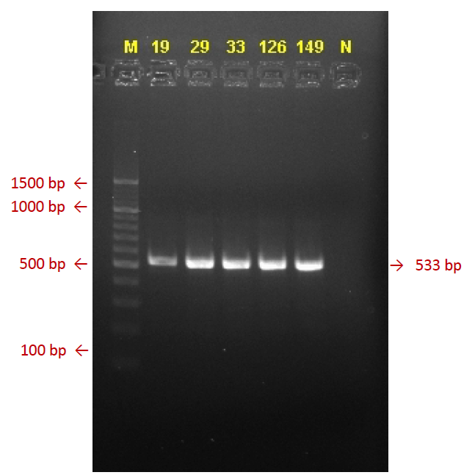
Figure S2. Visualisation of PCR product of CYP2B6 516G>T

