Male
Female
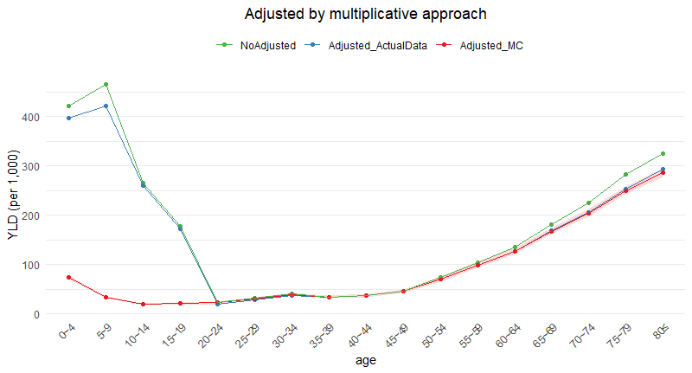
MC, Monte-Carlo simulation; YLD, Years lived with disability
Supplemental Material 1. Multimorbidity-adjusted YLD by methodology (per 1,000 population)

