Table S1. The equations of epidemiologic indicators in the article
Number | Equation
Equation 1. | Point prevalence  $= \frac{Number of cases of a disease present in the population at a specified time}{Number of persons in the population at that moment}$ $×1000$
Equation 2. | Period prevalence  $$= \frac{Number of cases of a disease present in the population at a specified period}{Average number of persons in the population at that period} ×1000$$
Equation 3. | Cumulative incidence rate $= \frac{\begin{aligned}Number of new cases of a disease occurring in the population \\ during a specified period of time\end{aligned}}{\begin{aligned}Number of persons who are \left(disease-free and\right) at risk of developing the disease \\ during that period of time\end{aligned}}$ $×1000$
Equation 4. | Person-time incidence rate  $$= \frac{Number of new cases of a disease occurring in a population during a specified period of time}{Total person-time (∑Person-Time)}$$
Equation 5. | $Overall attack rate= \frac{Number of new cases}{Number of total population}×100$ (or $×1000)$  $Primary attack rate=$ $\frac{Number of new cases among denominator}{\begin{aligned}Number of susceptible people \\ exposed to the source of the disease \end{aligned}}×100$ (or $×1000)$
Equation 6. | Secondary attack rate  $= \frac{Number of new cases developed during the maximum incubation period of the pathogen}{Number of susceptible people who were in contact with the primary cases }$ $×100$  $= \frac{Number of new cases developed during the maximum incubation period of the pathogen}{Number of susceptible household members who were in contact with the primary cases }$ $×100$
Equation 7. | Crude death rate $=$ $\frac{Number of crude deaths during a specified year}{\begin{aligned}Number of average \left(or midpoint\right) population \\ during that year\end{aligned}}$ $×1000$
Equation 8. | $Cause-specific death rate=$ $\frac{ Number of deaths due to a specific cause during a specified year }{Number of average \left(or midpoint\right) population during that year}$ $×100000$
Equation 9. | $Age-specific death rate=$ $\frac{Number of deaths in a specific age group}{Number of population in a specific age group}$ $×100000$
Equation 10. | $Sex-specific death rate =$ $\frac{Number of deaths in a specific sex}{Number of population of that sex} ×100000$
Equation 11. | Female age-specific death rate, age 30 to 44  $$= \frac{\begin{aligned}Number of deaths in women aged 30-44 \\ due to breast cancer in a specified year\end{aligned}}{Midpoint population number of women aged 30-44 in that year}×100000$$
Equation 12. | Case-fatality rate ($\%)=$ $\frac{Number of patients who die from a specific disease in a specific period}{Number of patients with that disease in that period}$ $×100$
Equation 13. | Death-to-case ratio = $\frac{Number of deaths from a specific disease in a certain period}{Number of new cases of that disease detected in that period}$ $×100$
Equation 14. | Proportional mortality$\left(\%\right)=$ $\frac{Number of deaths from a specific cause in a specified year}{Number of total deaths in that year}$ $×100$
Equation 15. | $Proportional mortality ratio$ $= \frac{PM of specific population B}{PM of specific population A}$ $×100$  Or $\frac{Observed PM in specific population B}{Expected PM in standard population}$ $×100$
Equation 16. | $$Infant mortality rate= \frac{\begin{aligned}Number of deaths in a specified year of \\ children less than 1 year of age\end{aligned}}{Number of live births in the same year}×1000$$
Equation 17. | $Neonatal mortality rate=\frac{Number of deaths in infants under 28 days of age in a given period}{Number of live births in the same period}$ $×1000$
Equation 18. | $$α-index = \frac{Infant mortality rate}{Neonatal mortality rate}$$
Equation 19. | $$Perinatal mortality rate= \frac{Number of perinatal deaths }{Total births in perinatal period}×1,000$$  $$= \frac{ Fetal deaths from the completion of gestational week 22 plus neonatal deaths in a given period}{Fetal deaths from the completion of gestational week 22+ live births in a given period }×1000$$
Equation 20. | $Maternal mortality ratio (MMR)$  $$= \frac{Number of maternal deaths due to pregnancy, childbirth and postpartum complications in a specified year}{Number of births in that year}×100000$$
Equation 21. | C$rude birth rate= \frac{\begin{aligned}Number of live births in residents \\ in an area in a specified year\end{aligned}}{\begin{aligned}Average or midyear population \\ in the area in that year\end{aligned}}×1000$
Equation 22. | $$General fertility rate= \frac{Number of live births during a year}{\begin{aligned}Midyear female population aged 15-49 \\ in the same area in the same year\end{aligned}}×1000$$
Equation 23. | $$Age-specific fertility rate= \frac{\begin{aligned}Number of live births occurring \\ during a specified year in women \\ of a specific age group\end{aligned}}{\begin{aligned}Number of person-years lived \\ during that year \\ by women of that age group\end{aligned}}×1000$$
Equation 24. | $$Total fertility rate= \sum_{x=15}^{49}{Age-specific fertility rate }$$

Table S2. The examples and questions of epidemiologic indicators explained in this article
Number | Question and answer
Question 1. | Forty new cases of disease A have occurred in a community of 1000 individuals who had never experienced the disease for the previous 10 years. What is the cumulative incidence rate of disease A in this community?
Answer 1. | The cumulative incidence rate of disease A = 40/1000 for 10 years. Alternatively, the cumulative incidence rate of disease A in this community is 4 cases per 1000 person-years.
Question 2 | Figure 1 shows the number of people in a sample population at various time points and the number of cases who developed a disease for various durations. Calculate the prevalence on January 1, 1991 and on December 31, 1993. Express the rate per 10000 population.
Answer 2. | Point prevalence on January 1, 1991 = 2/1000 × 10000 = 20 patients per 10000 population  Point prevalence on December 31, 1993 = 3/2000 × 10000 = 15 patients per 10000 population
Question 3. | Calculate the period prevalence from January 1, 1992 to December 31, 1992, using (a) the midpoint population of people alive on July 1, 1992 as the denominator, and (b) the average number of persons in the population from the beginning and the end of 1992 as the denominator
Answer 3. | (a) 6/1300 × 10000 = 46 cases per 10,000 population  (b) 6/([1200+1500]/2) × 10000 = 44 cases per 10000 population
Question 4. | Calculate the period prevalence from January 1, 1991 to December 31, 1993, using the average number of persons in the population from the beginning to the end of the period.
Answer 4. | Period prevalence from 1991 to 1993 = 10 / ([1000+2000]/2) × 10000 = 67 patients per 10000 population
Question 5. | Calculate the cumulative incidence rate of disease A per 10000 population from January 1, 1991 to December 31, 1993, using the average number of persons in the population from the beginning to the end of the period.
Answer 5. | Numerator = 8 new cases (the ninth and tenth patients are excluded because they were diagnosed prior to the period of interest)  Denominator = (The average number of persons in the population from January 1, 1991 to December 31, 1993) – 2 (the ninth and tenth patients who became no longer susceptible to the disease)  Therefore, the cumulative incidence per 10000 population  = $\frac{(10 [total number of patients]- 2 [prevalent cases diagnosed before 1991])}{\left(Average number of the population from 1991 to 1993\right)- 2 (prevalent cases)} ×10,000$  = 8 / 1498 $×10000$ = 0.67 cases per 10000 in 3 years
Question 6. | Figure S2 shows a population in which cardiovascular disease occurred in some individuals. Calculate the person-time incidence rate of cardiovascular disease in this population.
Answer 6. | Numerator = 5 cases observed during 7 years of follow-up  Denominator = Sum of susceptible person-years of the healthy population observed = 40 person-years  Person-time incidence rate = 12.5 cases per 100 person-years (note that the person-time after onset of disease is not counted).
Question 7. | Calculate the cumulative incidence rate of cardiovascular disease.
Answer 7. | (During 7 years of observation)  Numerator = Number of new cases observed (5)  Denominator = Sum of susceptible persons (10)  Cumulative incidence rate = 50 cases per 100 population per 7 years
Question 8. | Calculate the average duration of cardiovascular disease in the population of figure S2.
Answer 8. | Prevalence = Incidence × (Average) Duration  Numerator = Total duration of illness (11 years)  Denominator = Total number of incident cases (5)  Therefore, the average duration is 2.2 years.
Question 9. | Table S3 shows a summary of data from the Middle East respiratory syndrome (MERS) outbreak in hospital A, where the index case was hospitalized in 2015. The index case was in ward B from May 15 to May 17. Subsequently, from May 15 to May 21, 13 of 70 inpatients in ward B were confirmed as MERS cases. In ward C, where patients who had not been diagnosed with MERS in ward B were transferred, 7 additional cases of MERS were confirmed from May 20 to May 29. Calculate the attack rate among nurses in ward B of hospital A when the index case was hospitalized in 2015. Sixteen nurses were on duty during the exposure period, and two confirmed cases were reported within 14 days (the maximum incubation period of MERS) after the index case left.
Answer 9. | Attack rate = (2 ⁄ 16) × 100% = 12.5%
Question 10. | Table S4 shows the general characteristics and numbers of deaths of MERS-confirmed patients in hospital A during the 2015 Middle East respiratory syndrome (MERS) outbreak in Korea. Calculate the case-fatality rate among all patients.
Answer 10. | 6/36 $×$ 100 = 16.7%
Question 11. | In table S4, shen sex- and age-specific fatalities are compared, which characteristic affected fatality most strongly?
Answer 11. | Case-fatality rate among males: 15.0% (=3/20), case-fatality among females: 18.8% (=3/16); case-fatality rate in 20- to 49-year-olds: 0%, case-fatality rate in 50- to 69-year-olds: 23.1% (=3/13), case-fatality rate in 70- to 79-year-olds: 50.0% (=3/6).
Question 12. | The health bureau from a country reported a total of 15075 new patients with tuberculosis in 2002, and 802 tuberculosis deaths in the same period. Calculate the death-to-case ratio in 2002 and interpret it.
Answer 12. | $\frac{802}{15075}×100=5.3$%  5.3 deaths occurred per 100 new tuberculosis cases. This indicator is a ratio, not a proportion, since most mortality cases in 2002 were new tuberculosis cases prior to 2002. Most of the 802 deaths probably did not occur among the 15075 new patients.

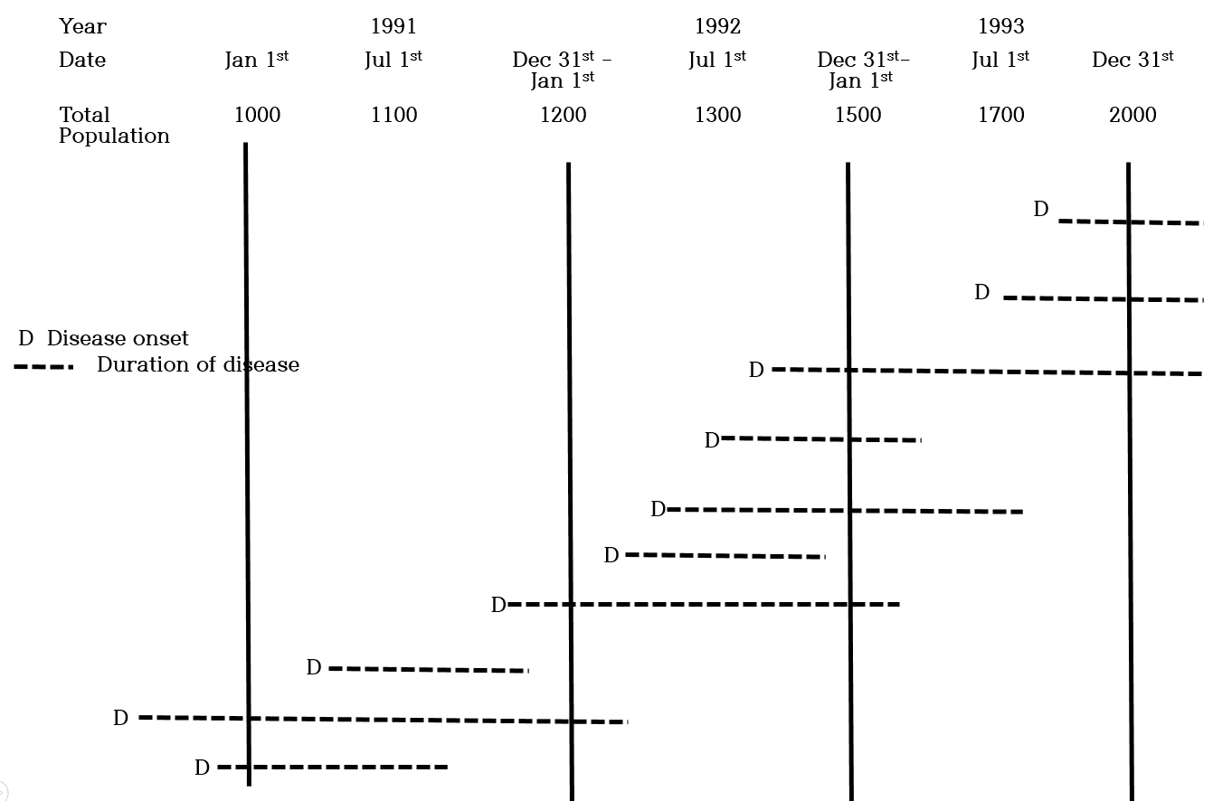

Figure S1. An example of several prevalent cases of disease A in a sample population between 1991 and 1993.

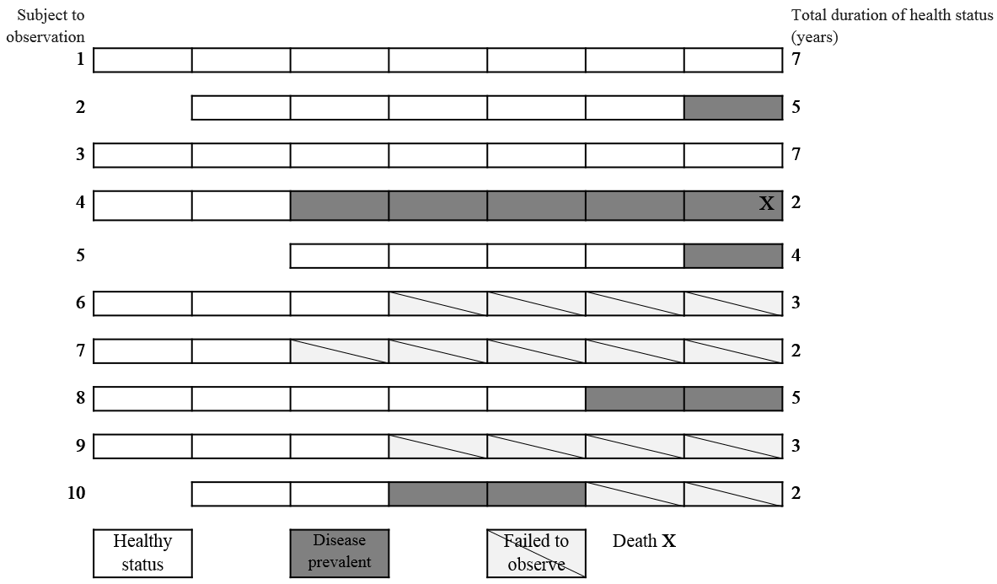
Figure S2. An example of the 10 new cases of coronary artery disease in a region.

Table S3. Outbreak status of Middle East respiratory syndrome (MERS) at hospital A, Korea, 2015
 | Inpatients who stayed in the same ward as MERS cases or a nearby ward |  | Healthy persons who were in contact with MERS cases
 | Ward B  (May 15-21) | Ward C  (May 20-29) | Caregivers,  visitors | Nurses in ward B | Nurses in ward C
Total (n) | 70 | 148 | 277 | 16 | 20
Confirmed cases | 13 | 7 | 3 | 2 | 1
Source from: Kim KM et al., 2015.

Table S4. General characteristics and numbers of deaths of MERS-confirmed patients
Characteristics |  | n (%) |  | Deaths (n)
Total |  | 36 (100) |  | 6
Sex | Male | 20 (55.5) |  | 3
 | Female | 16 (44.4) |  | 3
Age (y) | 20-49 | 17 (47.2) |  | 0
 | 50-69 | 13 (36.1) |  | 3
 | 70-79 | 6 (16.7) |  | 3
Infection | Primary | 26 (72.2) |  | 4
 | Secondary | 10 (27.8) |  | 2
Source from: Kim KM et al., 2015

