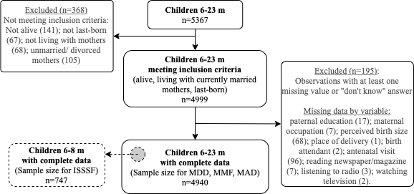

Supplemental Material 1. Sample selection stages. ISSSF, introduction of solid, semi-solid, and soft foods; MAD, minimum acceptable diet; MDD, minimum dietary diversity; MMF, minimum meal frequency.

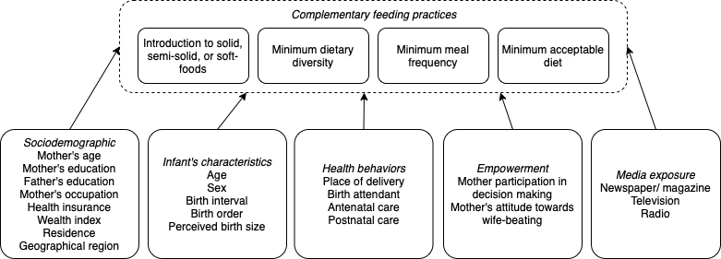

Supplemental Material 2. Conceptual framework for the predictors of complementary feeding practices. Adapted from Ng. et al. (2012) and Walters et al. (2019)

Ng CS, Dibley MJ, Agho KE. Complementary feeding indicators and determinants of poor feeding practices in Indonesia: a secondary analysis of 2007 Demographic and Health Survey data. Public Health Nutr. 2012 May;15(5):827–39.
Walters C, Walters C, Rakotomanana H, Komakech J, Barbara Stoecker, Barbara Stoecker, et al. Maternal determinants of optimal breastfeeding and complementary feeding and their association with child undernutrition in Malawi (2015–2016). BMC Public Health. 2019 Nov 11;19(1):1–12.

