- Prostate cancer
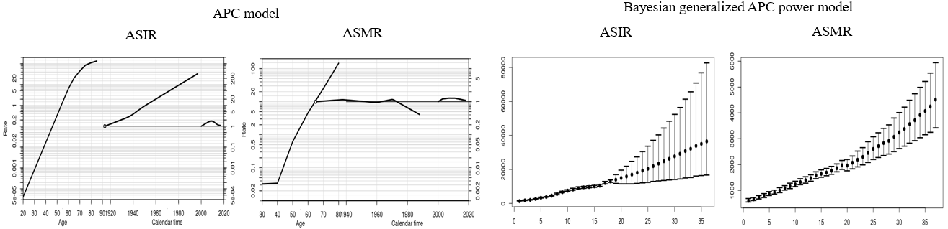
- Female breast cancer
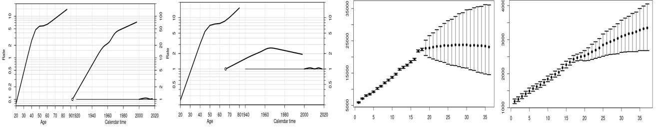
APC analysis | Terms in model | Summary statistics
 |  | Deviance (df) | △D (△ df) | Effect | p-value | Adj-$R^{2}$
Prostate
Incidence | Age | 13,484.29 (247) | - | - | - | -
 | Age+drift | 4,117.09 (246) | 9,367.20 (1) | δ | A | < 0.0001 | 0.69
 | Age+period | 1,312.61 (243) | 12,171.68 (4) | P | A | < 0.0001 | 0.90
 | Age+cohort | 3,961.66 (243) | 9,522.63 (4) | C | A | < 0.0001 | 0.70
 | Age+period+cohort | 896.87 (240) | 3,064.79 (3) | P | AC | < 0.0001 | 0.93
 |  |  | 415.74 (3) | C | AP | < 0.0001
Mortality | Age | 379.94 (204) | - | - | - | -
 | Age+drift | 379.79 (203) | 0.15 (1) | δ | A | < 0.0001 | 0.00
 | Age+period | 283.72 (200) | 96.22 (4) | P | A | < 0.0001 | 0.24
 | Age+cohort | 275.46 (200) | 104.48 (4) | C | A | < 0.0001 | 0.26
 | Age+period+cohort | 236.37 (197) | 39.09 (3) | P | AC | < 0.0001 | 0.36
 |  |  | 47.34 (3) | C | AP | < 0.0001
Breast
Incidence | Age | 20,114.87 (247) | - | - | - | -
 | Age+drift | 4,840.30 (246) | 15,274.57 (1) | δ | A | < 0.0001 | 0.76
 | Age+period | 4,702.24 (243) | 15,412.63 (4) | P | A | < 0.0001 | 0.76
 | Age+cohort | 3,184.83 (243) | 16,930.04 (4) | C | A | < 0.0001 | 0.84
 | Age+period+cohort | 3,078.99 (240) | 105.84 (3) | P | AC | < 0.0001 | 0.84
 |  |  | 1,623.25 (3) | C | AP | < 0.0001
Mortality | Age | 1,195.02 (204) | - | - | - | -
 | Age+drift | 1,015.60 (203) | 179.42 (1) | δ | A | < 0.0001 | 0.15
 | Age+period | 1,003.47 (200) | 191.54 (4) | P | A | < 0.0001 | 0.14
 | Age+cohort | 892.92 (200) | 302.10 (4) | C | A | < 0.0001 | 0.24
 | Age+period+cohort | 882.47 (197) | 10.44 (3) | P | AC | < 0.0001 | 0.24
 |  |  | 121.00 (3) | C | AP | < 0.0001
Abbreviation: df, degree of freedom; △D, difference of deviance; △df, difference of the degree of freedom; δ|A, δ effect adjusted by age; P|A, period effect adjusted by age; C|A, cohort effect adjusted by age; P|AC, period effect adjusted by age and cohort; C|AP, cohort effect adjusted by age and period
Supplemental Material 15. Age, cohort and period effects for the rates of prostate and female breast cancers in the age-period-cohort (APC) model (first curve, age effect; second curve, cohort effect; third curve, period effect) and the forecasts of cancer rates in the Bayesian generalized APC power model (x-axis means the calendar year, such as 0=2000, 5=2005, 10=2010, 15=2015 (the year of observation); 20=2020, 25=2025, 30=2030, 35=2035 (the predicted year); y-axis means the number of observed or estimated cancer cases; The fan shows the predictive distribution of cancer cases from the 5% to the 95% value; dot, mean predictive value) (Abbreviation: ASIR, age-standardized incidence rates; ASMR, age-standardized mortality rates).

