Lung cancer
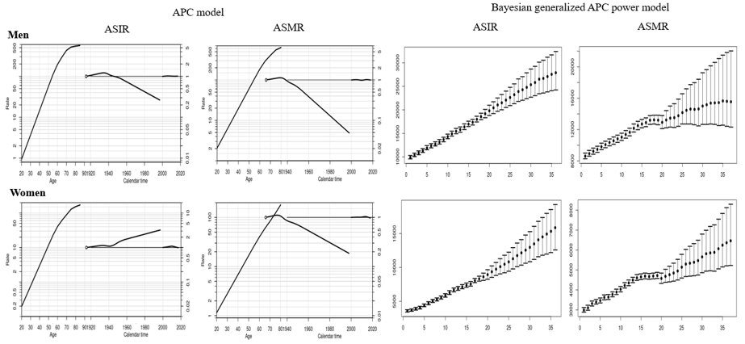
APC analysis | Terms in model | Summary statistics
 |  | Deviance (df) | △D (△ df) | Effect | p-value | Adj-$R^{2}$
Incidence
Men | Age | 2,626.74 (247) | - | - | - | -
 | Age+drift | 1,468.26 (246) | 1,158.48 (1) | δ | A | < 0.0001 | 0.44
 | Age+period | 1,433.47 (243) | 1,193.27 (4) | P | A | < 0.0001 | 0.45
 | Age+cohort | 602.38 (243) | 2,024.36 (4) | C | A | < 0.0001 | 0.77
 | Age+period+cohort | 597.00 (240) | 5.38 (3) | P | AC | < 0.0001 | 0.77
 |  |  | 836.47 (3) | C | AP | < 0.0001
Women | Age | 1,484.01 (247) | - | - | - | -
 | Age+drift | 1,127.34 (246) | 356.67 (1) | δ | A | < 0.0001 | 0.24
 | Age+period | 1,045.11 (243) | 438.90 (4) | P | A | < 0.0001 | 0.28
 | Age+cohort | 794.66 (243) | 689.35 (4) | C | A | < 0.0001 | 0.46
 | Age+period+cohort | 693.54 (240) | 101.12 (3) | P | AC | < 0.0001 | 0.52
 |  |  | 351.57 (3) | C | AP | < 0.0001
Mortality
Men | Age | 7,540.71 (242) | - | - | - | -
 | Age+drift | 2,784.10 (241) | 4,756.62 (1) | δ | A | < 0.0001 | 0.63
 | Age+period | 2,716.79 (238) | 4,823.92 (4) | P | A | < 0.0001 | 0.63
 | Age+cohort | 547.22 (238) | 6,993.50 (4) | C | A | < 0.0001 | 0.93
 | Age+period+cohort | 526.76 (235) | 20.46 (3) | P | AC | < 0.0001 | 0.93
 |  |  | 2,190.03 (3) | C | AP | < 0.0001
Women | Age | 1,610.59 (242) | - | - | - | -
 | Age+drift | 891.77 (241) | 718.81 (1) | δ | A | < 0.0001 | 0.44
 | Age+period | 811.66 (238) | 798.91 (4) | P | A | < 0.0001 | 0.49
 | Age+cohort | 562.66 (238) | 1,047.92 (4) | C | A | < 0.0001 | 0.64
 | Age+period+cohort | 543.03 (235) | 19.63 (3) | P | AC | < 0.0001 | 0.65
 |  |  | 268.64 (3) | C | AP | < 0.0001
Abbreviation: df, degree of freedom; △D, difference of deviance; △df, difference of the degree of freedom; δ|A, δ effect adjusted by age; P|A, period effect adjusted by age; C|A, cohort effect adjusted by age; P|AC, period effect adjusted by age and cohort; C|AP, cohort effect adjusted by age and period
Supplemental Material 12. Age, cohort and period effects for the rates of lung cancer in the age-period-cohort (APC) model (first curve, age effect; second curve, cohort effect; third curve, period effect) and the forecasts of cancer rates in the Bayesian generalized APC power model (x-axis means the calendar year, such as 0=2000, 5=2005, 10=2010, 15=2015 (the year of observation); 20=2020, 25=2025, 30=2030, 35=2035 (the predicted year); y-axis means the number of observed or estimated cancer cases; The fan shows the predictive distribution of cancer cases from the 5% to the 95% value; dot, mean predictive value) (Abbreviation: ASIR, age-standardized incidence rates; ASMR, age-standardized mortality rates).

