Liver cancer
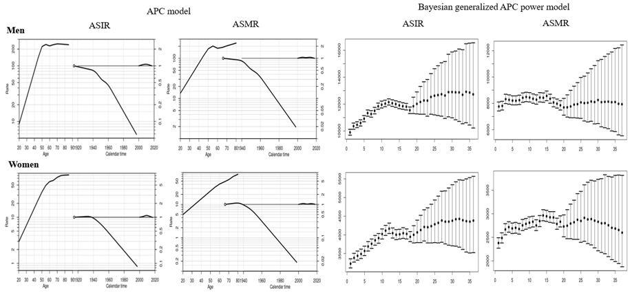
APC analysis | Terms in model | Summary statistics
 |  | Deviance (df) | △D (△ df) | Effect | p-value | Adj-$R^{2}$
Incidence
Men | Age | 7,777.36 (247) | - | - | - | -
 | Age+drift | 2,572.11 (246) | 5,205.25 (1) | δ | A | < 0.0001 | 0.67
 | Age+period | 2,403.44 (243) | 5,373.92 (4) | P | A | < 0.0001 | 0.69
 | Age+cohort | 1,479.72 (243) | 6,297.64 (4) | C | A | < 0.0001 | 0.81
 | Age+period+cohort | 1,379.34 (240) | 100.39 (3) | P | AC | < 0.0001 | 0.82
 |  |  | 1,024.11 (3) | C | AP | < 0.0001
Women | Age | 2,205.58 (247) | - | - | - | -
 | Age+drift | 1,052.92 (246) | 1,152.65 (1) | δ | A | < 0.0001 | 0.52
 | Age+period | 955.05 (243) | 1,250.53 (4) | P | A | < 0.0001 | 0.56
 | Age+cohort | 529.16 (243) | 1,676.42 (4) | C | A | < 0.0001 | 0.76
 | Age+period+cohort | 463.81 (240) | 65.34 (3) | P | AC | < 0.0001 | 0.78
 |  |  | 491.23 (3) | C | AP | < 0.0001
Mortality
Men | Age | 11,378.70 (242) | - | - | - | -
 | Age+drift | 3,323.08 (241) | 8,055.62 (1) | δ | A | < 0.0001 | 0.71
 | Age+period | 3,235.40 (238) | 8,143.30 (4) | P | A | < 0.0001 | 0.71
 | Age+cohort | 1,355.06 (238) | 10,023.64 (4) | C | A | < 0.0001 | 0.88
 | Age+period+cohort | 1,315.27 (235) | 39.79 (3) | P | AC | < 0.0001 | 0.88
 |  |  | 1,920.13 (3) | C | AP | < 0.0001
Women | Age | 3,238.98 (242) | - | - | - | -
 | Age+drift | 1,618.90 (241) | 1,620.08 (1) | δ | A | < 0.0001 | 0.50
 | Age+period | 1,582.75 (238) | 1,656.23 (4) | P | A | < 0.0001 | 0.50
 | Age+cohort | 459.38 (238) | 2,779.60 (4) | C | A | < 0.0001 | 0.86
 | Age+period+cohort | 445.34 (235) | 14.04 (3) | P | AC | < 0.0001 | 0.86
 |  |  | 1,137.41 (3) | C | AP | < 0.0001
Abbreviation: df, degree of freedom; △D, difference of deviance; △df, difference of the degree of freedom; δ|A, δ effect adjusted by age; P|A, period effect adjusted by age; C|A, cohort effect adjusted by age; P|AC, period effect adjusted by age and cohort; C|AP, cohort effect adjusted by age and period
Supplemental Material 11. Age, cohort and period effects for the rates of liver cancer in the age-period-cohort (APC) model (first curve, age effect; second curve, cohort effect; third curve, period effect) and the forecasts of cancer rates in the Bayesian generalized APC power model (x-axis means the calendar year, such as 0=2000, 5=2005, 10=2010, 15=2015 (the year of observation); 20=2020, 25=2025, 30=2030, 35=2035 (the predicted year); y-axis means the number of observed or estimated cancer cases; The fan shows the predictive distribution of cancer cases from the 5% to the 95% value; dot, mean predictive value) (Abbreviation: ASIR, age-standardized incidence rates; ASMR, age-standardized mortality rates).

