Supplemental Material 1. Comparison among major CKD cohort studies
 | 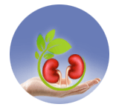  KNOW-CKD  Phase I and II | 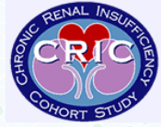  CRIC  Phase I and III | 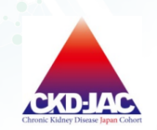  CKD-JAC
Nation | Korea | USA | Japan
Starting recruitment (year) | Phase I: 2011  Phase II: 2019 | 2001 | 2007
Recruitment centers (N) | Phase I: 9  Phase II: 14 | 11 | 17
Subjects enrolled (N) | Phase I: 2,238  Phase II: 1,500 (enrollment target) | 5,439 | 2,975
CKD stage  (non-dialysis dependent) | CKD stage 1 to 5 | CKD stage 3 to 5  (eGFR 10-60 ml/min/1.73 m²) | CKD stage 3 to 5  (eGFR 10-60 ml/min/1.73 m²)
Biosamples | Serum, plasma, urine, DNA | Plasma, urine, DNA | Plasma, urine
Laboratory test | Creatinine, cystatin C, iPTH,  25OHD, 1,25OHD, troponin T, urine: creatinine, albumin, protein, and electrolyte | Iothalamate-based clearance, creatinine, | Creatinine, cystatin C, HbA1C, iPTH,  urine: creatinine, albumin, and creatinine clearance
Other test | Echocardiography,  DEXA,  HRQoL | ECG, echocardiography | ABPM, HRQoL
Outcomes | CV event, death, eGFR, ESKD, hospitalization, HRQoL | CV event, death, eGFR, ESKD , hospitalization, HRQoL | CV event, death, eGFR, ESKD , hospitalization, HRQoL
Publications | 87 | 250 | 19
HRQoL, health-related quality of life; HbA1c, hemoglobin A1c; ECG, electrocardiogram; DEXA, dual energy x-ray absorptiometry; CV, cardiovascular; Cr, creatinine; 25(OH)D, 25-hydroxyvitamine D; 1,25(OH)D, 1,25-dihydroxyvitamin D; iPTH, intact parathyroid hormone; ESKD, end-stage kidney disease; CRIC: Chronic Renal Insufficiency Cohort; CKD-JAC: Chronic Kidney Disease Japan Cohort; KNOW-CKD : KoreaN Cohort Study for Outcomes in Patients With Chronic Kidney Disease

