Supplementary Material 2. Donabedian’s Quality framework for acute ischemic stroke
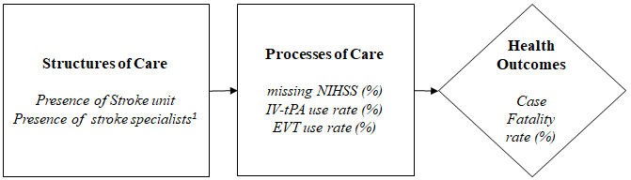
NIHSS, National Institute of Health Stroke Scale; IV-tPA, intravenous-recombinant tissue plasminogen activator; EVT, endovascular thrombectomy;
¹Stroke specialists are physicians with special skills in stroke such as neurology, neurosurgery, and rehabilitation medicine.

